**Final Capstone Project (London Boroughs)**

**By Sharif Alkhass**

**Introduction:**

The following project will be looking into helping someone trying to open a new establishment that sells food in and around of London. For this we will be looking into specific information relating to the different boroughs of London, this includes the types of restaurants, cafes and fast food establishments found in each borough, as well as how well new businesses did in the past, which should give us an idea of how well newly founded business preform in each area.

**Data:**

* First we obtain data regarding London boroughs <https://en.wikipedia.org/wiki/London_boroughs>
* Business preformance in each borough
* Use coordinates and foursquare to find our data relating to restaurants In this project we have used business-demographics from an online source <https://data.london.gov.uk/dataset/business-demographics-and-survival-rates-borough>.

**Methodology:**

The following will show the Methodology as well as the code used for our research. To start with we will be installing all the required packages and importing all the modules for our research, and we will add to the section if we require more packages not defines initially. Following this we will be using Forsquare to obtain data regarding each borough of London. To do this we scraped a webpage to obtain information regarding all the boroughs of London, the information from this is then used to find the coordinates for each borough. Once we have our coordinates we use Foursquare to find the local establishments witihin a specific radius. From here we organise our data and only display the top 10 for each borough. This will give us an idea of what which establishment performs best in which borough. After this we will use data regarding the performance of new business in each borough. This should help any clients looking at opening a new business in a specific borough as it will give them an idea of how well excepted new businesses are in the area they are looking at.

### Results

When we have analysed the data with regards to the new business demographics, it is clear that all of London seems to be upcoming in terms of new businesses and the rate at which new businesses are formed is increasing.

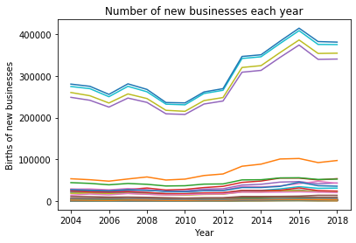

The amount of new businesses openning in a year depends also on the borough. Overall however, I believe it would be a wise decision to start a new business as a cafe somewhere in the region of central london like islington, or slightly north like Barnet. As these seem to have the highest births currently for food establishments.

The following image is an example of business birth for the borough of Croydon. Here we used LinearRegression while working with polynomialFeatures. The R^2 can be found for each of the results.

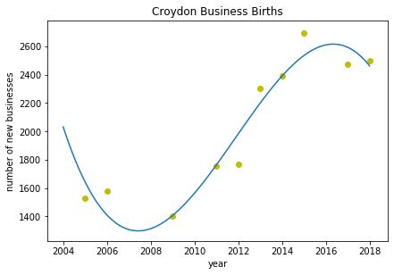

This is the table showing the results for the top establishments for each borough:

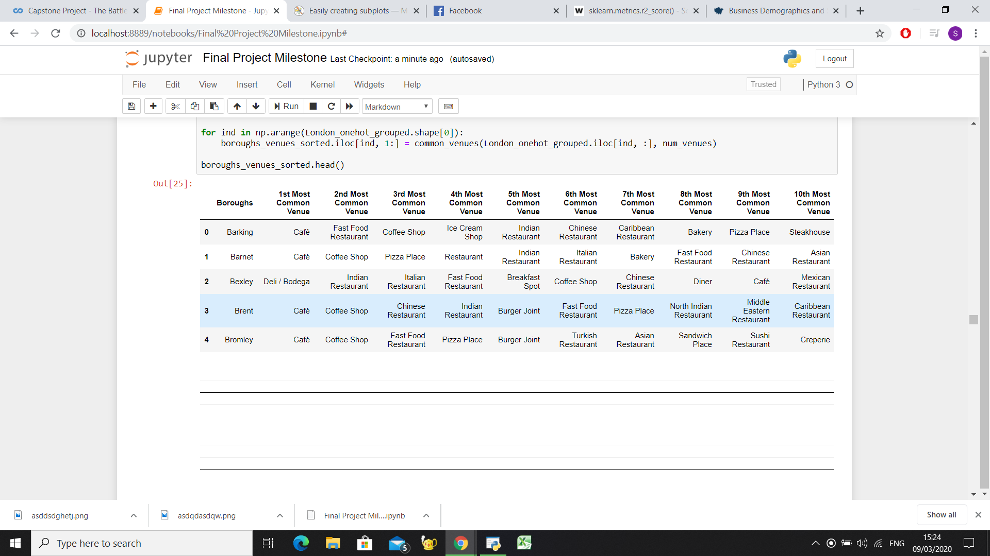 Following the table we have clustered all the boroughs and have plotted it on a map as shown below:

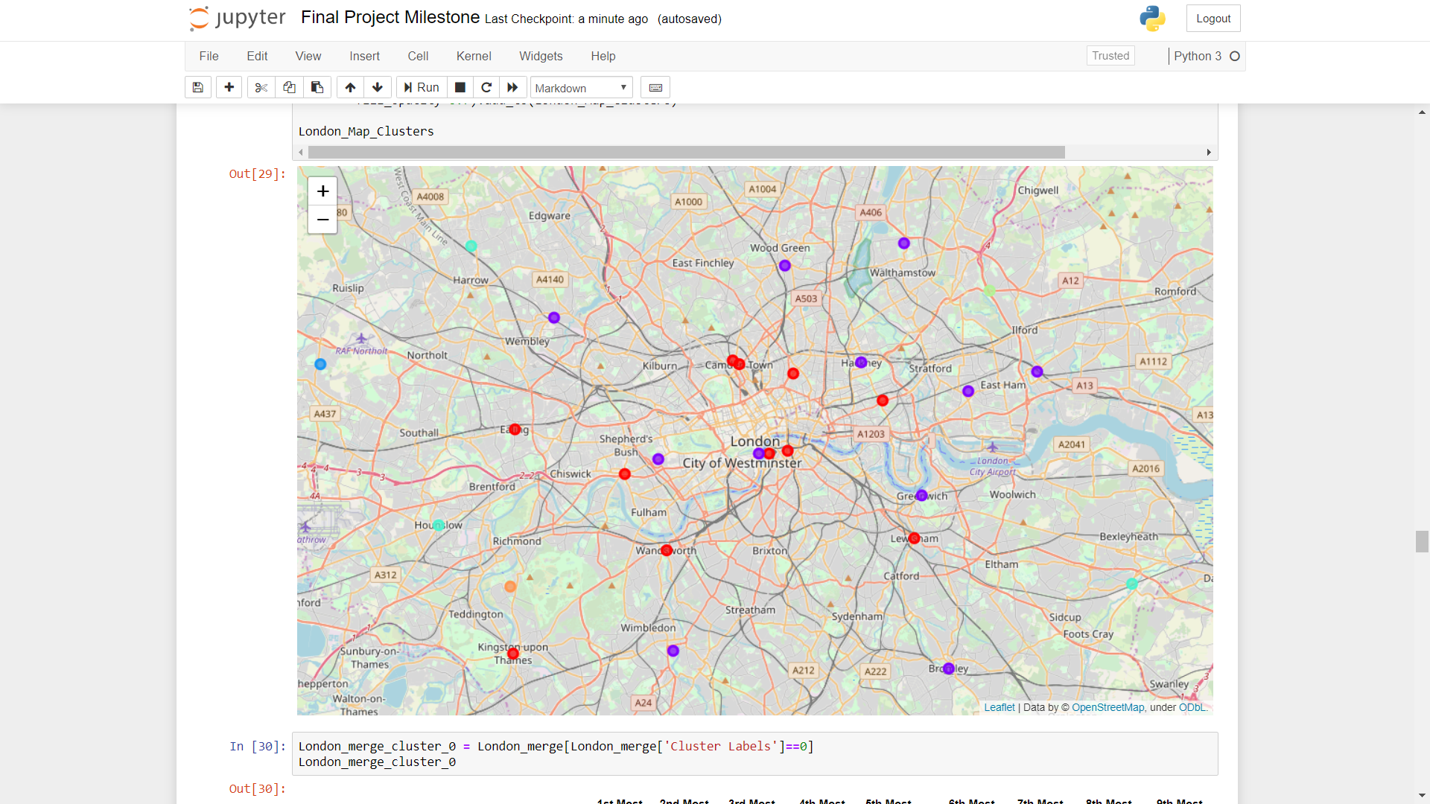

### Discussion:

Looking at the results that we have found we can see that the largest category of places that sells food around London are cafes however following that, the popularity of a specifc type of place would really depend on the borough that the client is looking to open their own business in. We can use the code here to find where specifically would be an ideal place for him to open depending on what kind of restaurant he is looking at.

When we have analysed the data with regards to the new business demographics, it is clear that all of London seems to be upcoming in terms of new businesses and the rate at which new businesses are formed is increasing. The amount of new businesses openning in a year depends also on the borough.

### Conclusion:

In conclusion I believe that there is alot more to look into in terms of demographics for a particular area. It would be beneficial to expand on our results to only include the rate of births and deaths of businesses in the food sector. This would give us an idea whether a specific borough are more acceptable of new businesses and how easy it would be to start.